|  |
| --- |
| Xbox Indie Game |
| Project Plan |
| Hugh Desmond – Software Development Year 4 |

10/18/2012

Contents

INTRO 2

1. The Purpose of the Project 2

2. Stakeholders 2

3. Project Definition 3

PLAN PREPERATION 3

4. Main Deliverables 3

5. Task Brainstorm – Documentation 4

6. Task Brainstorm – Game Elements/Features 5

7. Additional Considerations 8

PROJECT PLAN 8

8. Minimum to be produced 8

9. Approach and Methodology 9

10. Project Time Breakdown 9

11. Project Schedule 11

# INTRO

## 1. The Purpose of the Project

“To create an entertaining indie game on a low budget, which is to be released on a major platform and enjoyed by many people”

## 2. Stakeholders

### The Client/Customer

In the case of game development most if not all projects have one thing in common, they all share the same client, the general public. To be more specific my client is the Xbox gaming community which to date consists of approximately 66 million people. The Xbox platform is split into two infrastructures for the release of downloadable games: XBLA (Xbox Live Arcade) and XBLIG (Xbox Live Indie Games). XBLA is available in 26 countries whereas XBLIG is only available in 10, so this reduces my target audience somewhat.

### Project Supervisor

My Project Supervisor Mr Jim O’ Dwyer (head of computing at CIT) will be overseeing the project, advising me on how to proceed and grading me on my work.

### Cork Institute of Technology

This project is being carried out as part of my college course in Cork Institute of Technology, who will provide me with the necessary support to work on it and pass the module(s).

### Myself

Aside from simply passing the project related modules, it is of great interest to me to have a whole piece of work which is based on my own personal interests and I can be proud to show a future employer as part of my portfolio.

## 3. Project Definition

It is my personal goal to design and code a game which is playable on a popular console platform, in this case the Xbox. Microsoft released a special area of the Xbox arcade marketplace (XBLIG) where individual and lesser established game developers can sell their products for minimal publishing/development cost. I plan to use this platform to release my game where it will be available to download by the general public either for free or for a small fee. I aim to make a game which is entertaining for a relatively short period of time but is of a high quality. In terms of how the game plays I aim to challenge the player, rewarding them for overcoming challenges to stimulate them to keep playing. At the same time I don’t want to challenge the player so much so that the game becomes frustrating.

# PLAN PREPERATION

## 4. Main Deliverables

### Documentation

* Project Proposal Document
* Planning Document
* Requirements Specification Document
* Research Phase Project Report
* Research Phase Presentation
* Design Document
* Testing and Evaluation Document
* Full Project Presentation
* Full Project Report

### Code Build Types

* Focused Prototype (basic)
* Game Element Prototype
* Full Game Prototype
* Pre-Alpha
* Alpha
* Beta (Testing)
* Final

## 5. Task Brainstorm – Documentation

### Planning

* High level plan
* Schedule main milestones
* Choose a project tracking system (calendar)
* Choose file storage and sharing system for project files
* Choose and describe methodology for project

### Requirements Specification

* Intro
* Approach and Methodology
* Functional Requirements
* Non-Functional Requirements
* Business Case (budget, risks, analysis etc.)
* Requirements Research Outcomes
* High Level Use-Cases
* Issues
* Glossary

### Design Document

* Intro
* Use Cases
* Class Diagrams
* Menu system structure
* Level system structure
* Game behavior diagrams
* Artificial Intelligence diagrams
* Various other game specific diagrams

### Testing and Evaluation

* Evaluation – feedback and resulting changes
* Major bug log
* Testing Glossary
* Test Cases (categorized under different headings)
* Performance tests and review
* Various other game specific testing document elements

### Prototype Reports

* Goals of the prototype
* Learning outcomes
* Time breakdown (for more accurate future time estimates)

### Research Reports

* Topic and sub topics of research
* Learning outcomes

### Presentation

* Gathering/summarizing information
* Creating slides
* Create and rehearse notes

### Demo

* Simulate data and environment for the day
* Create script/schedule for the demo (breakdown the timing)
* Prepare equipment and hardware for the day
* Prepare access rights and special permissions for the day

## 6. Task Brainstorm – Game Elements/Features

### Core Engine (Basic)

* Static level drawn on screen (no scrolling)
* Character moveable with analog stick left and right
* Character collision with environment (vertical and horizontal)
* Character jump physics and collision
* Environmental threats to character (e.g. a gap, spikes)
* Interactive element of environment
* Basic character animation
* Basic environment animation
* Basic fire and forget sounds
* Basic enemy AI and player death on collision
* Single weapon shooting mechanic and enemy collision
* Basic player and enemy health system

### Level Engine

* Level collision system (for creating environmental collision bounds to a level)
* Sloped environment collision
* Moving environmental collision (vertical and horizontal)
* Moving environmental collision (diagonal and multidirectional)
* Level block/tile loading system
* Inter-level loading system
* Level area (screen portion) switching system (as opposed to scrolling)
* Level horizontal scrolling system
* Level horizontal and vertical scrolling system
* Possibility of zooming system
* Possibility of screen effects (e.g. screen shake)
* Possibility of a checkpoint system

### Collision and Physics (Advanced)

* Enemy attack collisions
* Vehicle physics and collision
* Alternate weapon collisions
* Special item collisions (pickup)
* Special environmental collisions (interactions)
* Finished level recognition
* Game state paused
* Throwing physics
* Wall bounce physics
* Button/switch collision
* Possibility of weather physics effect

### Menus and Rules

* Main Menu
* Splash and loading screens
* Heads up display and HUD animations
* Life/continue/checkpoint/level complete system
* Pause menu
* Level transition menu

### Animation and Art Assets

* Level art and animation
* Player animations (many also apply to enemies):
  + Run
  + Jump
  + Idle
  + Weapon aiming
  + Weapon shooting
  + Weapon idle
  + Pickup item / drop item
  + Special (e.g. finish level, finish game)
* Particle effects (vehicles, explosions)
* Item animations
* Possibility of Cut scene animations
* Background animations
* Menu art and animations
* HUD art and animations
* Icons and logos for the game
* Text in-game and menu fonts and font styles
* Screen transitions (animated)
* Possibility of credits screen

### Sound Assets

* Menu music and sounds
* Level specific music
* Fire and forget sounds (with several variations of each)
  + Player/enemy jump
  + Player/enemy shoot (per weapon)
  + Player/enemy reload (per weapon)
  + Player/enemy run
  + Player/enemy collide (per material)
  + Player/enemy special environmental (e.g. splash sound)
  + Item pickup
  + Checkpoint
  + Level end music/sounds
  + Game end music/sounds
  + Character chat/vocals
  + Button/switch/interactive item
* Special 3D sounds, programmed volume/pitch etc.
* Atmospheric sounds/tracks
* Sound options in menu/pause
* Stop/start sounds when game is interrupted

## 7. Additional Considerations

* A storyline/plot to drive the player along, in the form of cut-scene animations and/or text-based conversations with in-game characters or narrations
* A single goal/reason for why the player must do what they must do to complete each level and the game
* An overall theme to place boundaries in terms of the style and gameplay limitations of the game
* A setting for the game in terms of environment (fantasy made up world/based off real world)
* A setting for the game in terms of time (e.g. medieval times or futuristic)

# PROJECT PLAN

## 8. Minimum to be produced

* Basic menu with options to play and exit
* Minimum of 3 levels, each with unique themes and gameplay style
* 2 or more player weapons
* 3 or more types of enemies
* 3 or more types of interactive environmental features
* Horizontal scrolling of the level
* Basic art assets, sound assets and animations
* 3 or more ways the player can die by environmental dangers (platforming elements)
* 3 or more collectable items (e.g. power-up/weapon)
* Music unique to each level
* Basic heads-up-display and lives/checkpoint system
* 3 or more puzzles which must be solved to continue in a level
* Game is pause-able
* Easy-to-learn controls

## 9. Approach and Methodology

I have chosen to go with a flexible prototype-heavy approach to developing my game. After researching the methodology commonly used for games similar to what I plan to produce it seems it makes most sense to start development early with heavy emphasis on prototyping, getting things wrong and starting over, thus quickly improving and evolving. Both for me (inexperienced) and in general, game development has a lot of unknowns and often the best solution for better recognizing these unknowns is through trial and error.

My approach will be closer to an agile methodology then for example a waterfall model which is better suited to projects which have a more predictable outcome and are carried out by people who have the experience to boot. I will be constantly reviewing and revising each stage of the development cycle, but in general the revisions will become less frequent and more minor as time passes and deadlines approach.

## 10. Project Time Breakdown

### Description

In this section I will approximate how much actual time I may have to spend working on this project (i.e. Carrying out any project related task that takes time). Aside from class hours, I attempt to take into account time outside of class hours which will be spent completing labs and assignments, reviewing lecture notes, studying for exams, breaks (lunch/dinner), work (part-time job) and rest periods. I will not plan to fill every spare hour I have to work on the project but rather state a safe (or near-guaranteed) amount of hours which I have free and normally work within these time slots. I also state overflow hours which when added to the safe hours results in the maximum amount of hours I can expect to be free that day, I will reserve these overflow hours as fallback time for when the project is behind schedule and I need to crunch to catch-up.

### Cycle Length in Weeks

I declare the 15th of October 2012 as being the official starting point of the project as it is the point where the proposal was confirmed, a plan was put into place and work had been started on the project. From this point till the end of semester 1 is 8 weeks. During the interval between semesters there will be 1 week off over Christmas and 3 weeks in January (taking into account 1 week in January for exams), leaving a total of 4 free weeks. In the context of this project, I will call a week which I have off from college a free week, as I have significantly more free time to work on the project during these weeks. In semester 2 I have 13 college weeks and 2 free weeks (Easter break), leaving a total of 15 weeks. So in total, the development cycle will have a duration of 27 weeks (of which 6 are free weeks), ending on the final week of April 2013.

### Average Weekly Hours to Spare

|  |  |  |  |  |  |  |  |  |
| --- | --- | --- | --- | --- | --- | --- | --- | --- |
|  | Mon | Tue | Wed | Thu | Fri | Sat | Sun | **Total** |
| Max | 5 | 5 | 7 | 5 | 6 | 4 | 10 | 42 |
| Safe | 3 | 3 | 4 | 3 | 4 | 0 | 6 | 23 |
| Overflow | 2 | 2 | 3 | 2 | 2 | 4 | 4 | 19 |

### Average Free Week Hours to Spare

|  |  |  |  |  |  |  |  |  |
| --- | --- | --- | --- | --- | --- | --- | --- | --- |
|  | Mon | Tue | Wed | Thu | Fri | Sat | Sun | **Total** |
| Max | 10 | 10 | 10 | 10 | 10 | 4 | 10 | 10 |
| Safe | 6 | 6 | 6 | 6 | 6 | 0 | 6 | 36 |
| Overflow | 4 | 4 | 4 | 4 | 4 | 4 | 4 | 28 |

## 11. Project Schedule

I will be tracking my project meetings, milestones and delivery dates on Google calendars. I have made the calendar publicly available for the sake of simplicity and transparency. Here is an agenda summary of the key dates:

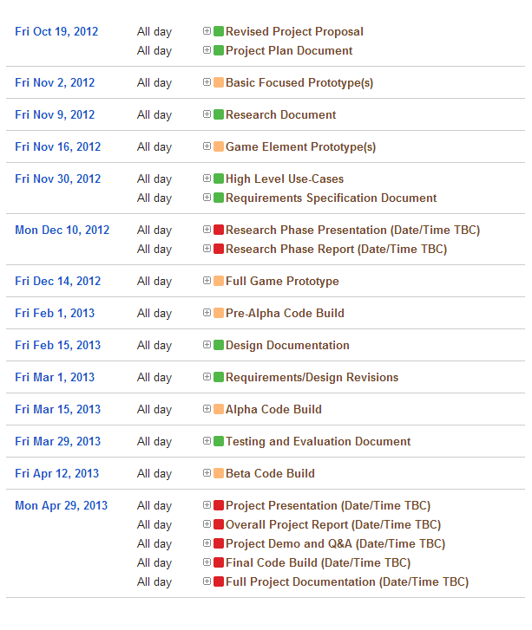

[Click here to see the Full Calendar](https://www.google.com/calendar/embed?src=mycit.ie_kvbhr98k556rusc47vh07mmq6k@group.calendar.google.com&ctz=Europe/Dublin&gsessionid=EDFY0H4o6fLwb4QNvJCOrg)